Nithin S
221IT085

IT150 Class Assignment

1. Write a C++ program to check the duplicate mobile number by throwing a custom exception.

The class named ContactDetail with the following private member variables:

Data typeVariable name string mobilenumber stringalternateMobilenumber stringemail
In ContactDetail class include the following member function:

Member FunctionDescription void display() : This function is used to display the contact
details

Create a class named ContactDetailBO with the following member function
Method name Descriptionbool validate(ContactDetail cd) :

This method is used to validate whether the mobile number and alternate mobile number
are not the same. If both are the same, then it
throws “DuplicateMobileNumber Exception”. Otherwise, return true to print the
details.
Class named DuplicateMobileNumberException that extends exception class and create a method to return the following message "DuplicateMobileNumberException".

CODE

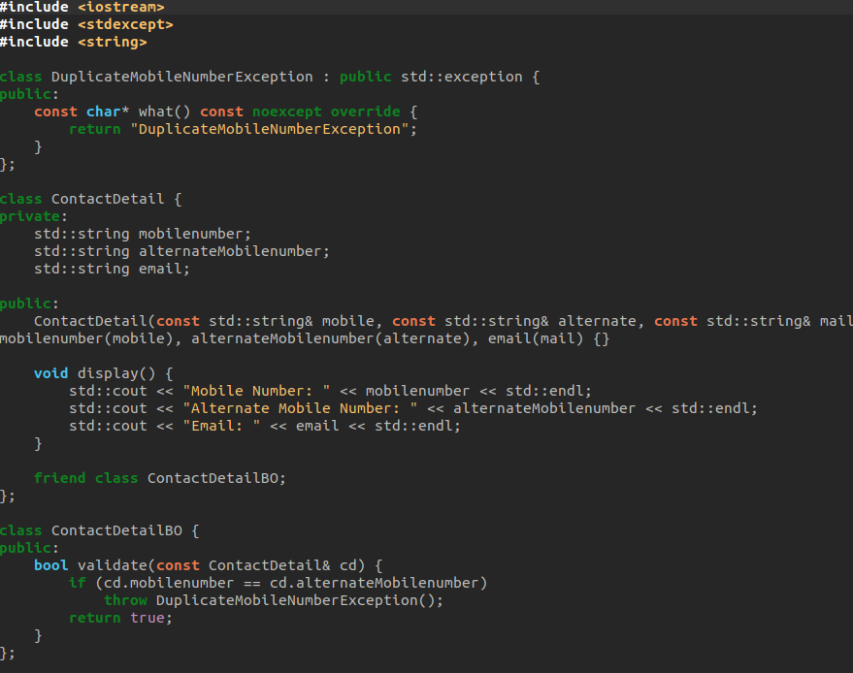

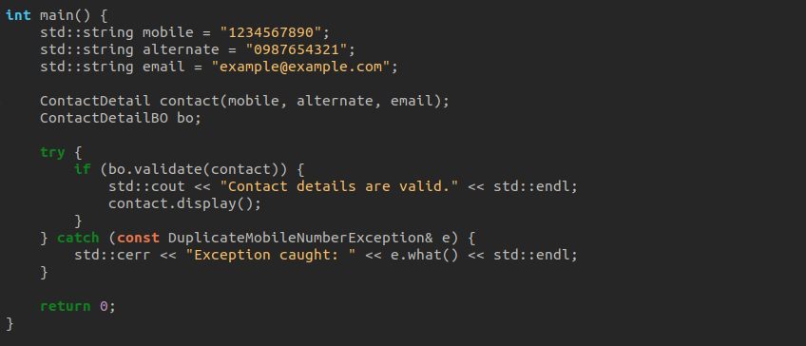

Output

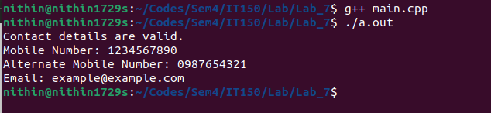

OUTPUT

